covid-19 / cORONA VIRUS BLUES

SHOPPING ADVENTURES

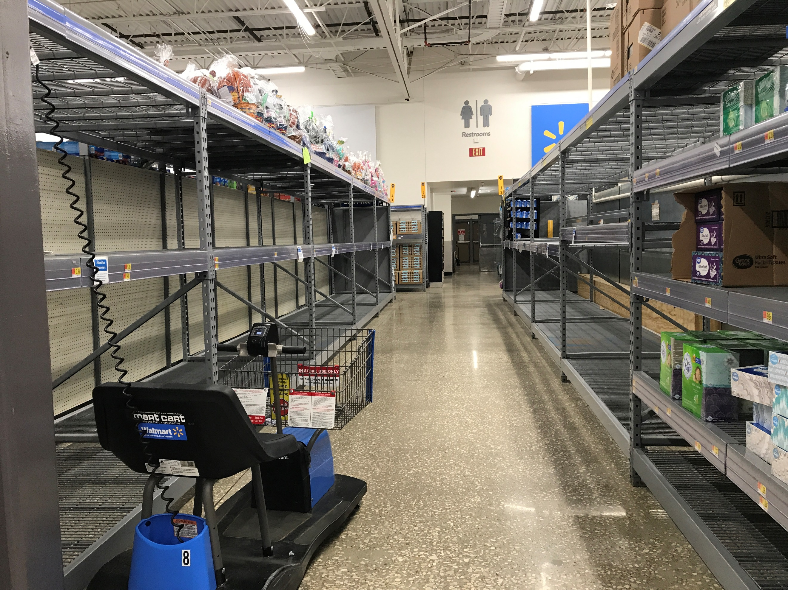
Paper Towel / TP Aisles Are Bare

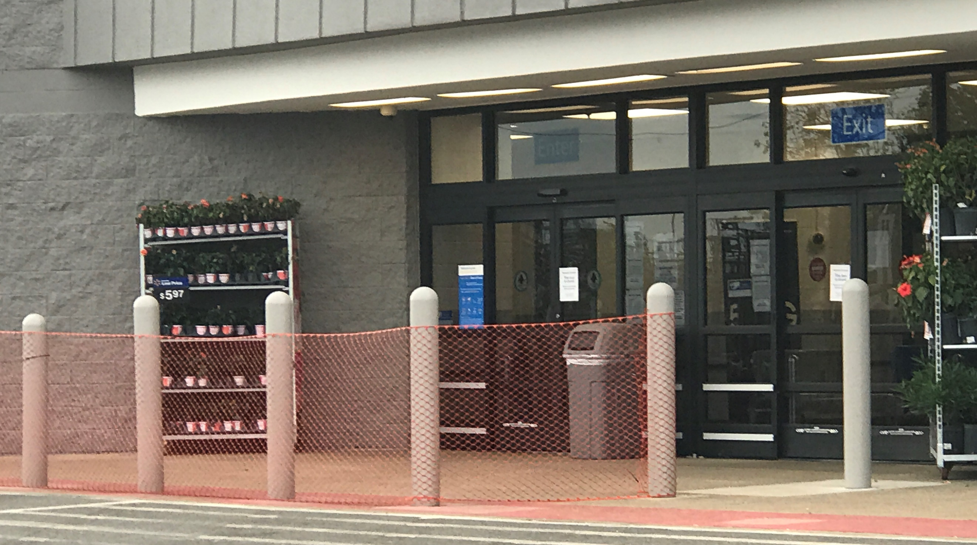
Controlling Entrances to stores

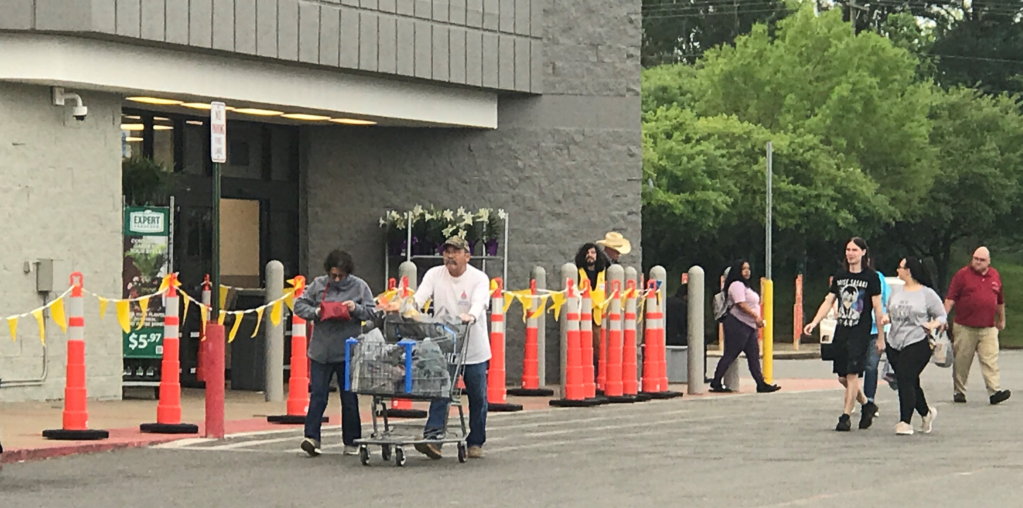
prepare to get in line & pick a #

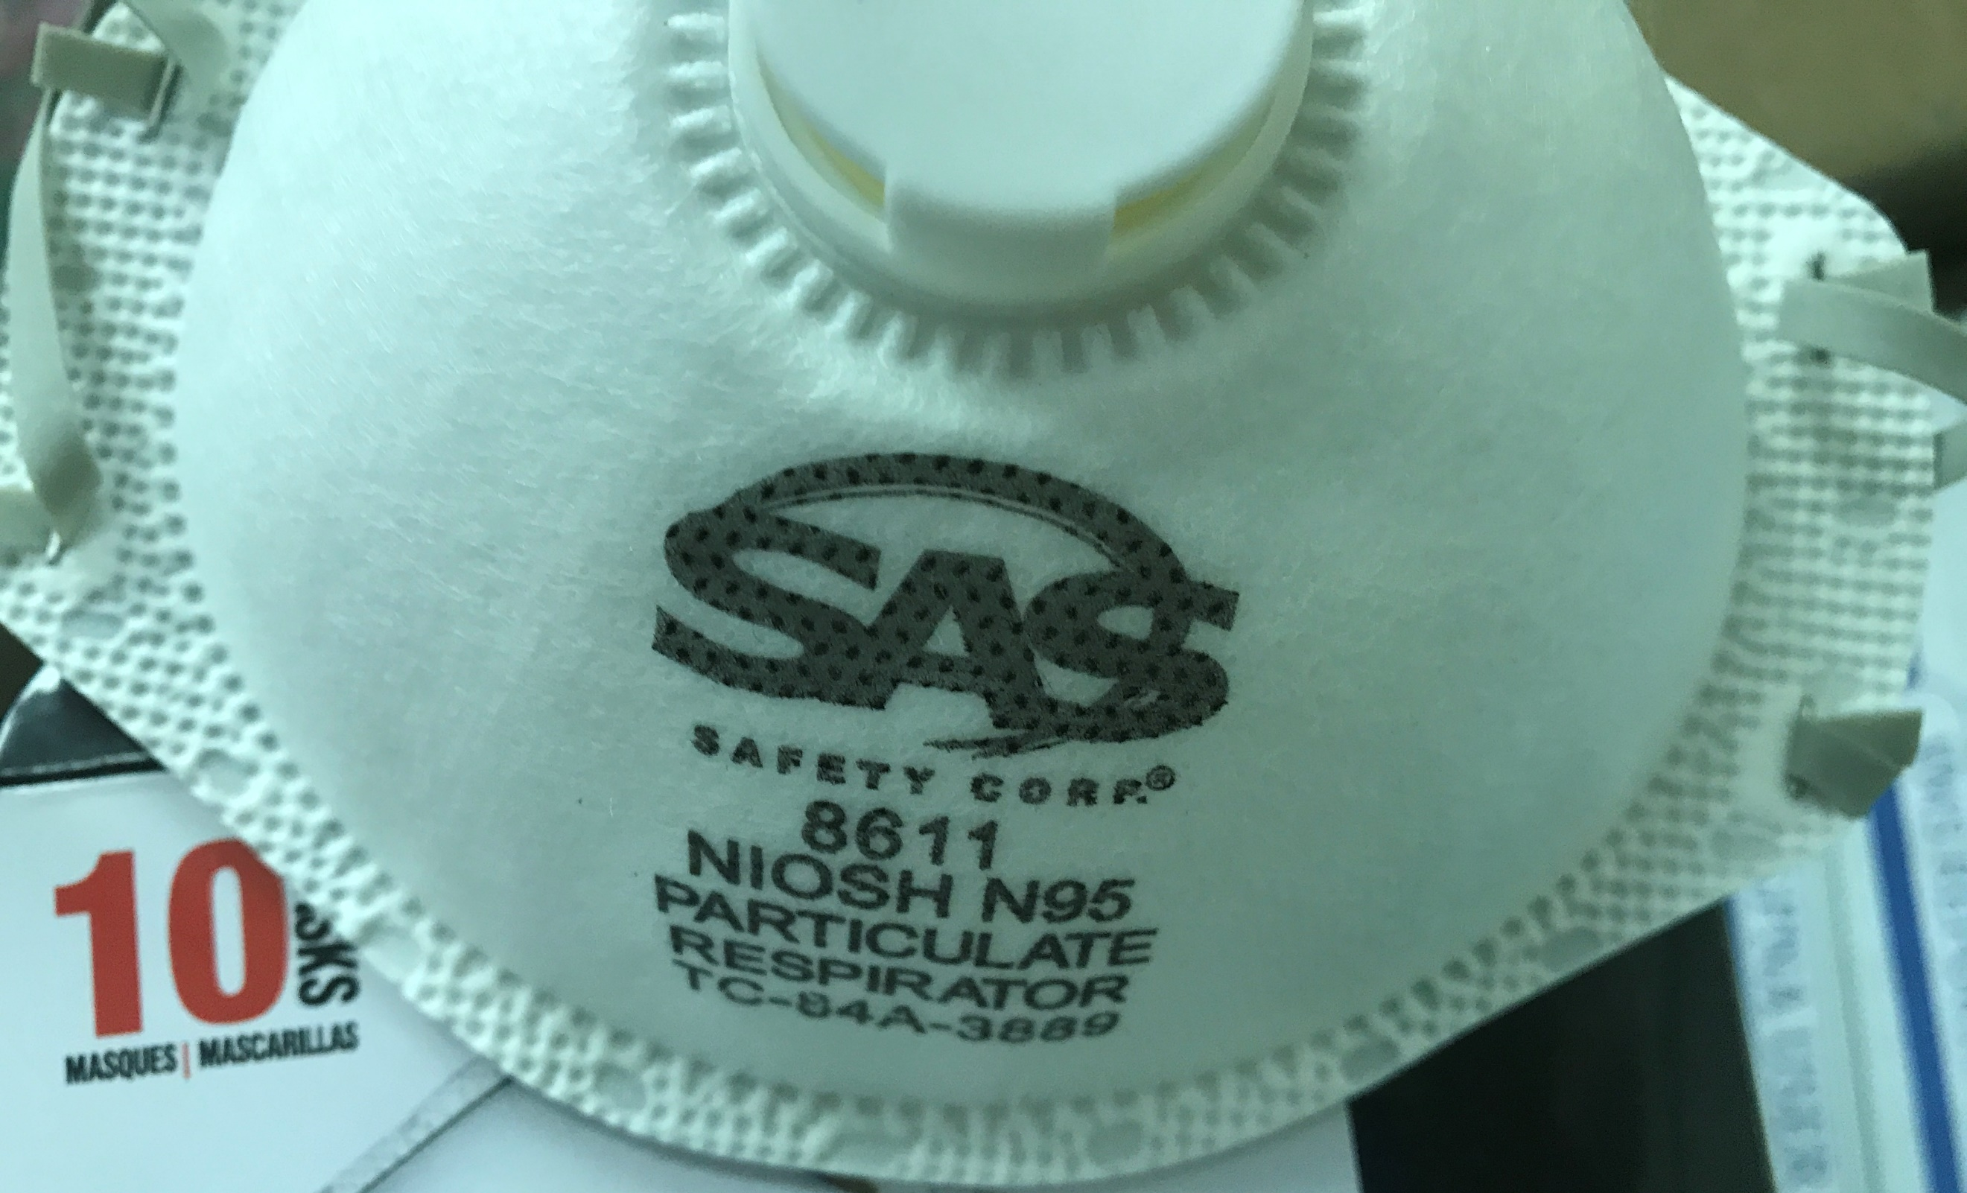
N95 Masks in short supply

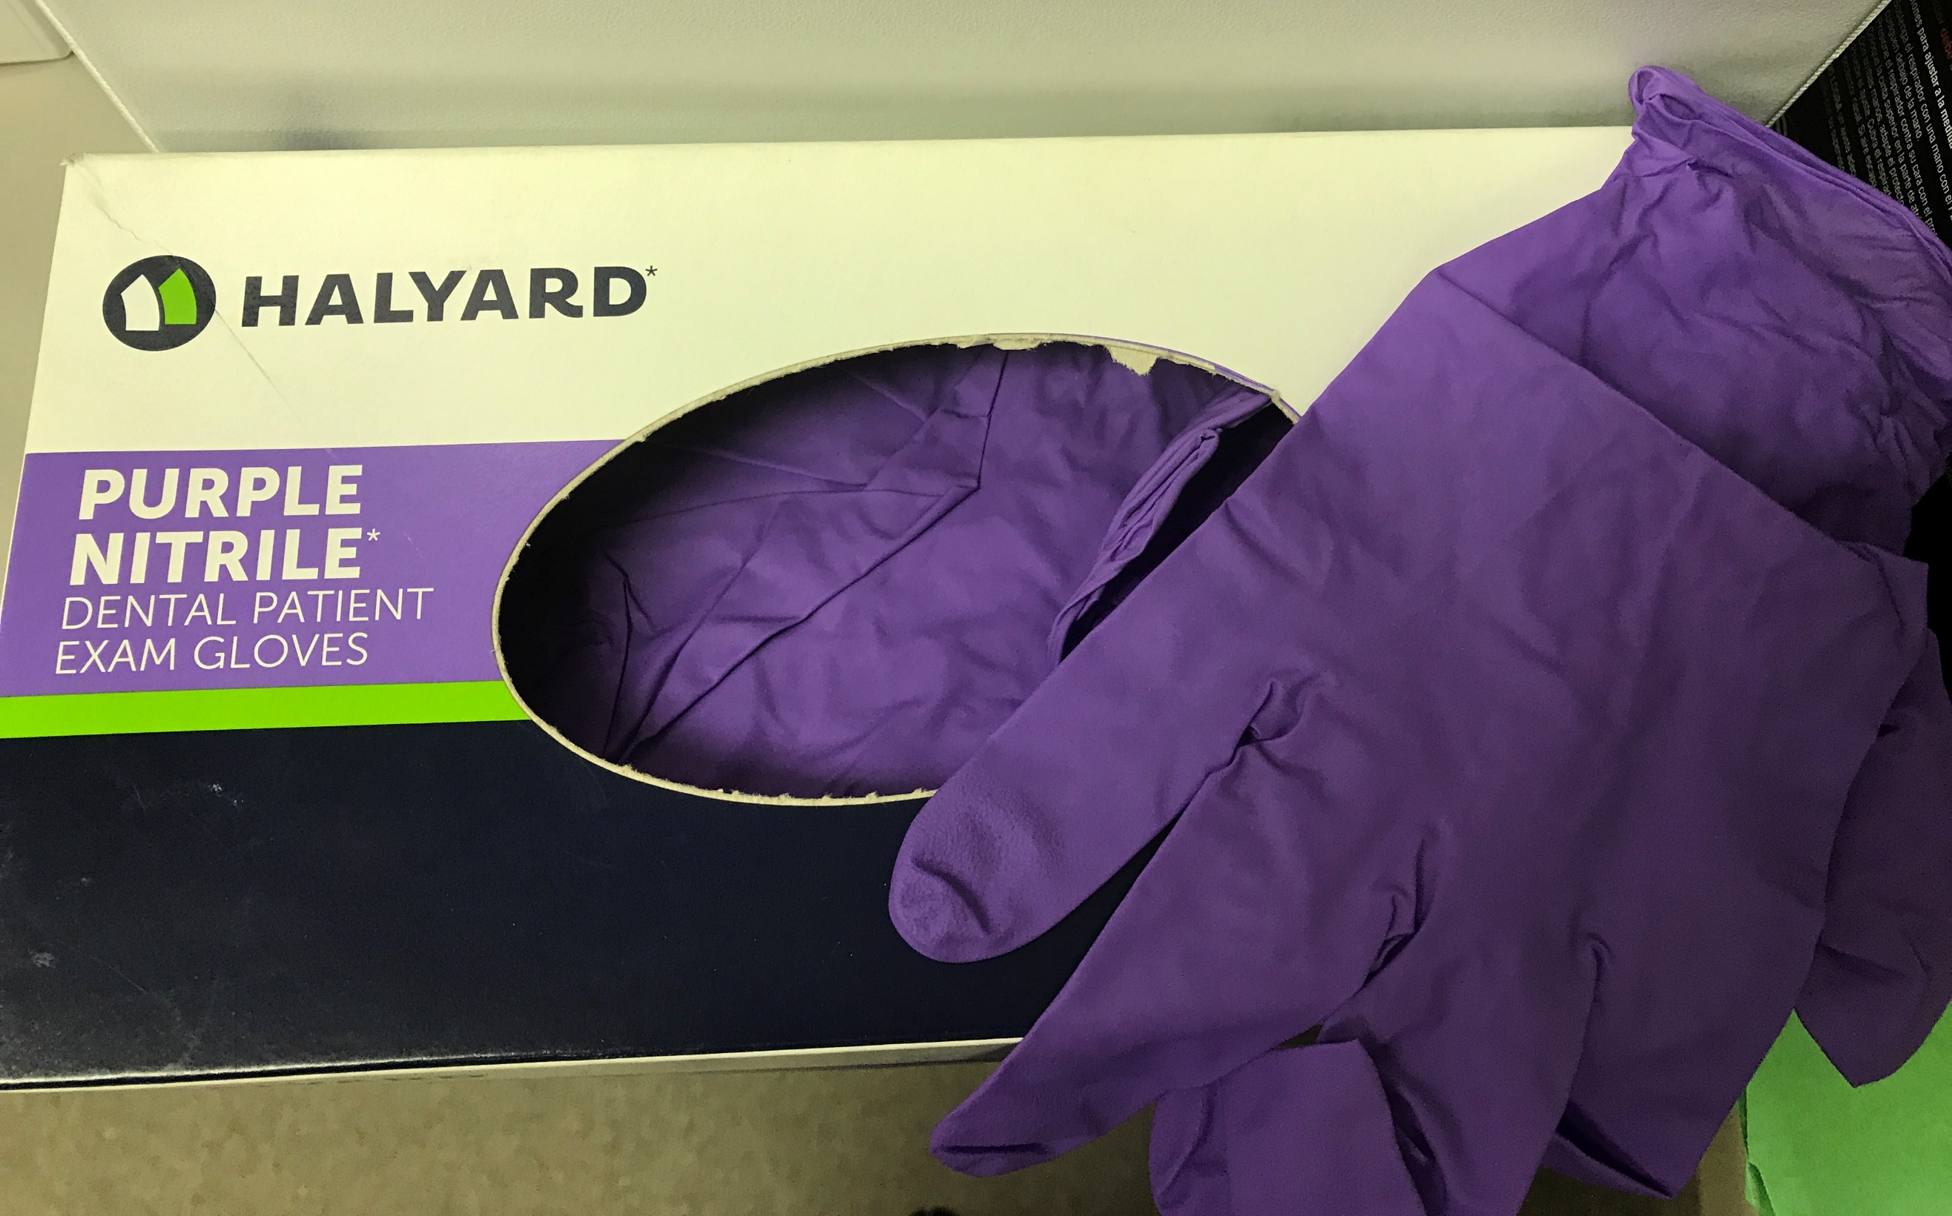
nitrile gloves hard to find

  - ALTO HOUSING AUTHORITY april 2020

SPRING-TIME NEWS
World-Wide Pandemic Causes Disruptions Even in East Texas!

Unless you’ve been living in a cave somewhere, you have without a doubt noticed that our world is changing rapidly with all of the restrictions now imposed upon us all in order to prevent the spread of this deadly virus now known as COVID-19. Regardless of the rocky start to plans to “flatten the curve” relative to our exposure, things are moving very fast indeed now and even the most skeptical among us has pretty much figured out that it is imperative that we all do our part to stay healthy.

OUR PART: Alto Housing Authority closed our doors to walk-in and face-to-face interviews effective Monday morning, March 16th. At that time, a Notice was prepared and distributed to all residents including the statement that we are ONLY responding to EMERGENCY or URGENT work orders until restrictions are lifted by the authorities. Staff will work from home, inside the office, in vacant units or on the grounds except for EMERGENCIES. If you call in a work order, you may be asked if it is “safe” for us to enter your unit. Please be honest. If anyone is feeling the least bit under the weather – let us know. While supplies last, we will make sure that N95 particulate masks are available to our staff, along with nitrile gloves should the situation warrant it. We will not be able to provide any PPE (Personal Protective Equipment) to RESIDENTS. No doubt you have all seen the empty paper product aisles at area stores, so you can understand that we need to use the products that we have in stock sparingly because we have no idea when we can restock our supplies. If there is an urgent repair that needs to be done and someone is not feeling well, but is still mobile, please step outside until repairs can be completed. Be patient with your requests for routine repairs. Those requests will be tabled for now and we’ll tackle those after restrictions are lifted.

YOUR PART: We are asking your cooperation during this difficult time to make sure we are ALL as safe as we can be. Until restrictions are lifted by the authorities, remember that we are all under a STAY-AT-HOME order unless (like Gail, Luis, Mary and our grounds and custodial contractors), you are deemed an ESSENTIAL EMPLOYEE. Stay-at-Home means exactly that. IF you are walking around outside and see another person – MAINTAIN A MINIMUM OF SIX FEET DISTANCE! Travel restrictions are tightening up, as well. If you are traveling outside of our area, there may be a mandatory quarantine upon your return to Alto. Check the local news before you go to avoid any unpleasant experiences upon your return.

As you clean/sanitize inside your own apartment – keep these things in mind:
BLEACH has proven itself to be an effective deterrent to the coronavirus IF the percentage of hyperchlorite is high enough. Make sure to mix the bleach from the bottle with water before you pour it directly on surfaces such as the vinyl floor tile in your unit.
If you are using germicidal WIPES – READ THE LABEL. Baby wipes are for gentle use and will NOT kill the corona virus!!! And make
ABSOLUTELY SURE that you NEVER put a wipe of any kind down the toilet.

PROTECT YOUR POTTY!
Only 3 things can go down the potty and they all start with the letter P. I think you can guess what the first two are – and the third one is toilet PAPER! The material that wipes are made from is NOT biodegradable and can (and certainly has in the past) cause serious problems in our plumbing systems. Used wipes should be placed in the regular household garbage cans. NEVER FLUSH WIPES!
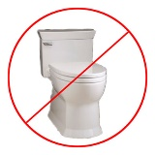

DO I HAVE TO PAY RENT?
Gosh! Do you have to even ask? Of course you continue to pay rent UNLESS you have reported an income change before the 20th of March! There ARE also several folks whose annual recertification for APRIL 1st has not yet been finalized. If you do not yet know what your NEW rent rate is for APRIL 2020, that probably means that I haven’t yet finished the calculations due to all of the madness related to the COVID-19 outbreak. Please be patient with me! If you haven’t heard from me about any CHANGE yet, pay your regular amount.

need TO report a change?
Slight Change in How to Do This During the COVID-19 Season

Whether you are an APPLICANT, a Public Housing RESIDENT or a Section 8 PROGRAM PARTICIPANT, if you have had a change in your income -- whether it is due to the corona virus business slow-down or any other reason, remember that you MUST REPORT YOUR CHANGE TO THE OFFICE IN WRITING WITHIN TEN DAYS OF THE DATE OF THE CHANGE. Since our office is closed to regular walk-in visits right now, you can drop one of those pink change forms we gave you during your recent annual recertification into the overnight drop box beside the front door OR you can e-mail us information about your change. Applicants will need to request a pink change form OR e-mail us. The office e-mail address for reporting changes is: INFO@AltoHA.com. If we need to contact your employer to verify your change (and we probably will), you may need to sign another document, which we'll send to you by mail (if you are a Section 8 client) or deliver to your apartment door (if you are a Public Housing resident). Sign it where indicated and then RETURN IT TO THE OFFICE. WE will send it to your employer. We can NOT accept change reports by telephone or voice mail. It's sweet that you thought to call us, but nothing is OFFICIAL unless it is in WRITING. 😊 Changes reported in writing before the 20th day of the month will be processed for the following month's rent amount. If we received your report AFTER the 20th day of the month, it won't impact your rent until the month AFTER NEXT.
MOWING SEASON HAS STARTED

Yup! Even during the Coronavirus slow down, our landscaping contractors are still working! Throughout the mowing season, you can expect them to be on site to mow -- normally about every two weeks. To make this as easy as it can be for the contractor, we ask your cooperation in a few things:
YARDS: Should be free of debris and/or trash such as cigar and cigarette butts. Toys, bicycles, lawn chairs and other personal items you use outdoors should be moved to the porch or inside one of the outdoor closets (if you have one!). Any furnishings that you have for your use outdoors must be MADE TO BE USED OUTDOORS or they must be disposed of or kept inside the apartment. This is a City of Alto ordinance and is enforceable by a fine of $250 per incident. Ouch. Easier just to -- NOT do it!
BBQ GRILLS should NEVER be stored INSIDE the unit or inside of any outdoor closet (if you have one) due to the risk of fire. When in use, the grill should be a minimum of 10' away from any building or structure. This is a State and Federal fire code regulation. We recommend that it is at least as far away from the buildings as your clothesline pole. When you're ready to dispose of spent charcoal, make ABSOLUTELY SURE that it is completely cool, put it in a suitable container and then into the dumpster. NEVER toss the charcoal onto the ground or (worse!) over the fence onto a neighboring property.

