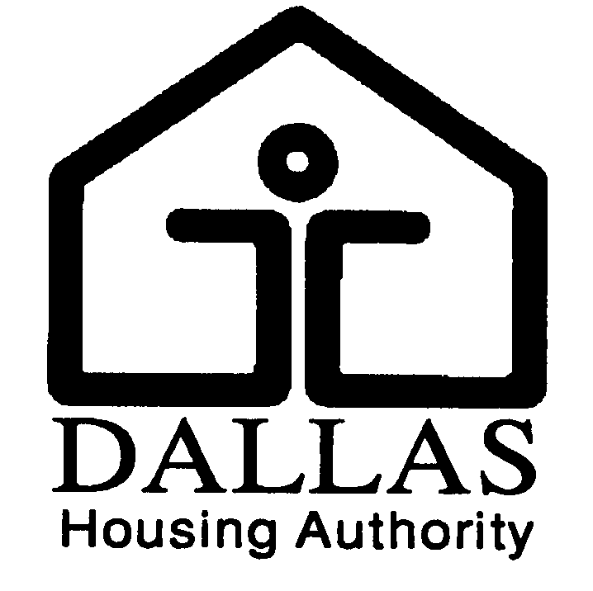
DALLAS HOUSING AUTHORITY
JOB DESCRIPTION

TITLE: |  | Facility Maintenance Technician | JOB CODE: 4015
PREPARED: |  | Updated March 2010 | FLSA: Non-Exempt

Summary: Under general supervision, maintains, repairs and rehabilitate the Authority’s properties, appliances and equipment.

Essential Job Functions: The following duties ARE NOT intended to serve as a comprehensive list of all duties performed by all employees in this classification. Shown are duties intended to provide a representative summary of the major duties and responsibilities. Incumbent(s) may not be required to perform all duties listed and may be required to perform additional, position-specific duties.

- Performs a variety of duties in the building maintenance and construction trades such as carpentry, plumbing, electrical, appliance repair and installation.
- Performs rough and finished carpentry construction and repair; such as replacing floors, furniture, cabinets and other wood items.
- Repairs holes in dry wall, hangs doors and installs paneling, wall partitions, ceilings and windows.
- Builds walls; installs, inspects and repairs roofing.
- Repairs water lines, unstops sewers, and repairs leaks. Installs water heaters, faucets and other plumbing fixtures.
- Installs ceiling fans, light fixtures, receptacles and switches.
- Sweeps, mops, vacuums, strips and waxes floors in buildings, stairways and restrooms.
- Ensures appliances and fixtures are in proper working order; changes light bulbs and air conditioning filters.
- Conducts move out inspections and completes work orders to ensure units are ready for new clients.
- Supports the relationship between DHA and the constituent population by demonstrating courteous and cooperative behavior when interacting with clients, visitors, and DHA staff.
- Enthusiastically promotes the President/CEO’s priorities for the operations of DHA.
- Perform scheduled P/M’s for units and building exteriors in compliance with UPCS.
- Perform scheduled P/M’s for the site and common areas in compliance with UPSC.
- Assist in the preparation of the scheduled HUD inspection.
- Performs other duties as assigned or required.

Knowledge and Skills:

- Knowledge of DHA policies and procedures.
- Knowledge of the equipment, materials, methods and techniques used in a variety of skilled construction and building maintenance tasks.
- Knowledge of applicable building codes, ordinances, fire regulations and safety precautions.
- Knowledge of occupational hazards and safety practices applicable to building maintenance and repair work.
- Skill in performing a variety of construction, maintenance, repair and remodeling tasks.
- Skill in operating a variety of equipment including heavy machinery, saws, pipe cutters and a variety of hand and power tools.
- Skill in reading blueprints, shop drawings and sketches.
- Skill in effective communication, both verbal and written.
- Skill in interacting with people of different social, economic, and ethnic backgrounds.

MINIMUM QUALIFICATIONS:

High School diploma or GED equivalent, and three (3) years of building maintenance or plumbing or electrical maintenance experience; OR an equivalent combination of education and experience.
State of Texas Drivers License.

