Comanche Housing Authority
404 East Cedar
Comanche, Texas 76442
Phone 325-356-3181
Fax 325-356-5591
Email – comanchetx@housingemail.com

Upcoming office closings:

Friday, April 2, 2021
Good Friday
Monday, May 31, 2021
Memorial Day

OFFICE PHONE
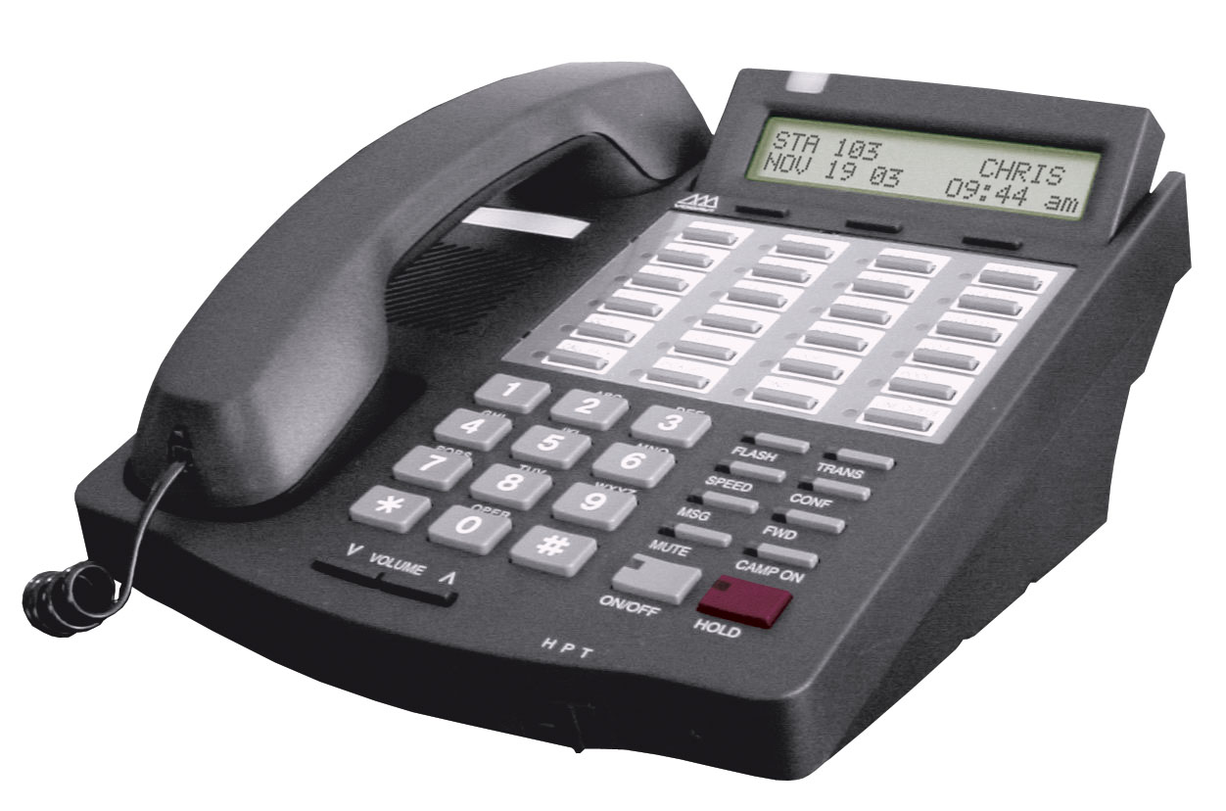
This Photo by Unknown Author is licensed under CC BY-ND
We are in the process of upgrading our phone and internet service once again. I would like to remind folks that if they have a maintenance issue during office hours to please call the main number- (325) 356-3181. For emergencies only, outside of normal business hours, call the emergency phone number at 325-330-0884. As a reminder, that number is for afterhours emergencies.

RENT

We now can accept rent via Credit/Debit Card with a virtual terminal. Although we enjoy visiting with our residents, there is no need to come to the office, you can call it in!

Sever Weather

We prayed that everyone made it through this unprecedented cold snap without injury or loss. We went without power for several days on Cimarron Trail, thank goodness for gas stoves. It made me very happy to see how much our residents kept a eye out for their neighbors and all the concern shown. Please keep a close eye on your plumbing over the next several weeks, if you notice any leaks, no matter how small, please give the office a call.

REMINDERS

PETS – If you have a pet, service animal or support animal, you are required to keep the animal on a leash. You must have the pet spayed or neutered, all required shots, signed agreement with the housing authority and it must be registered with the city. You are required to clean up after the animal. You are not allowed any outside food or water bowls. You are not allowed to tie you animal to any type of
cable or rope outside. Remember if your pet is outside, so are you.

Please take pride in your home – Please clean up your porches and yards. All it takes is a few minutes each day to keep your area picked up and clean. If someone drives by or walks by your apartment, what do they see? Is it neat and clean or is there trash everywhere or is it just a piled-up mess on the porch? We have had numerous complaints about trash blowing all over the place because it was not placed in a proper trash can or dumpster, front porches with inside furniture (as a reminder, only patio furniture can be left on the front or rear porch – no sofa’s or recliners) No indoor furniture in an outdoor area per your lease agreement as well as city ordinance.

Window Blinds and Storm Doors

Over the next couple of weeks Henri and I will be walking the property and surveying the number of miniblinds needing replacement in each unit, at the same time we will also be checking the latches on both the front and rear storm screen doors to ascertain how many need to be repaired. Once we have replaced the miniblinds in your unit, you will be responsible for any damages to the miniblinds.

Upcoming Federal Inspection

Over the next 90 days we will be preparing for the next mandated federal inspection of the housing authority. It is very important that we pass the inspection this year. It will affect the continued funding of our programs. You will be seeing several contactors working around the outside of the buildings and in the common areas, more details will be provided as they become available

LAWN CARE

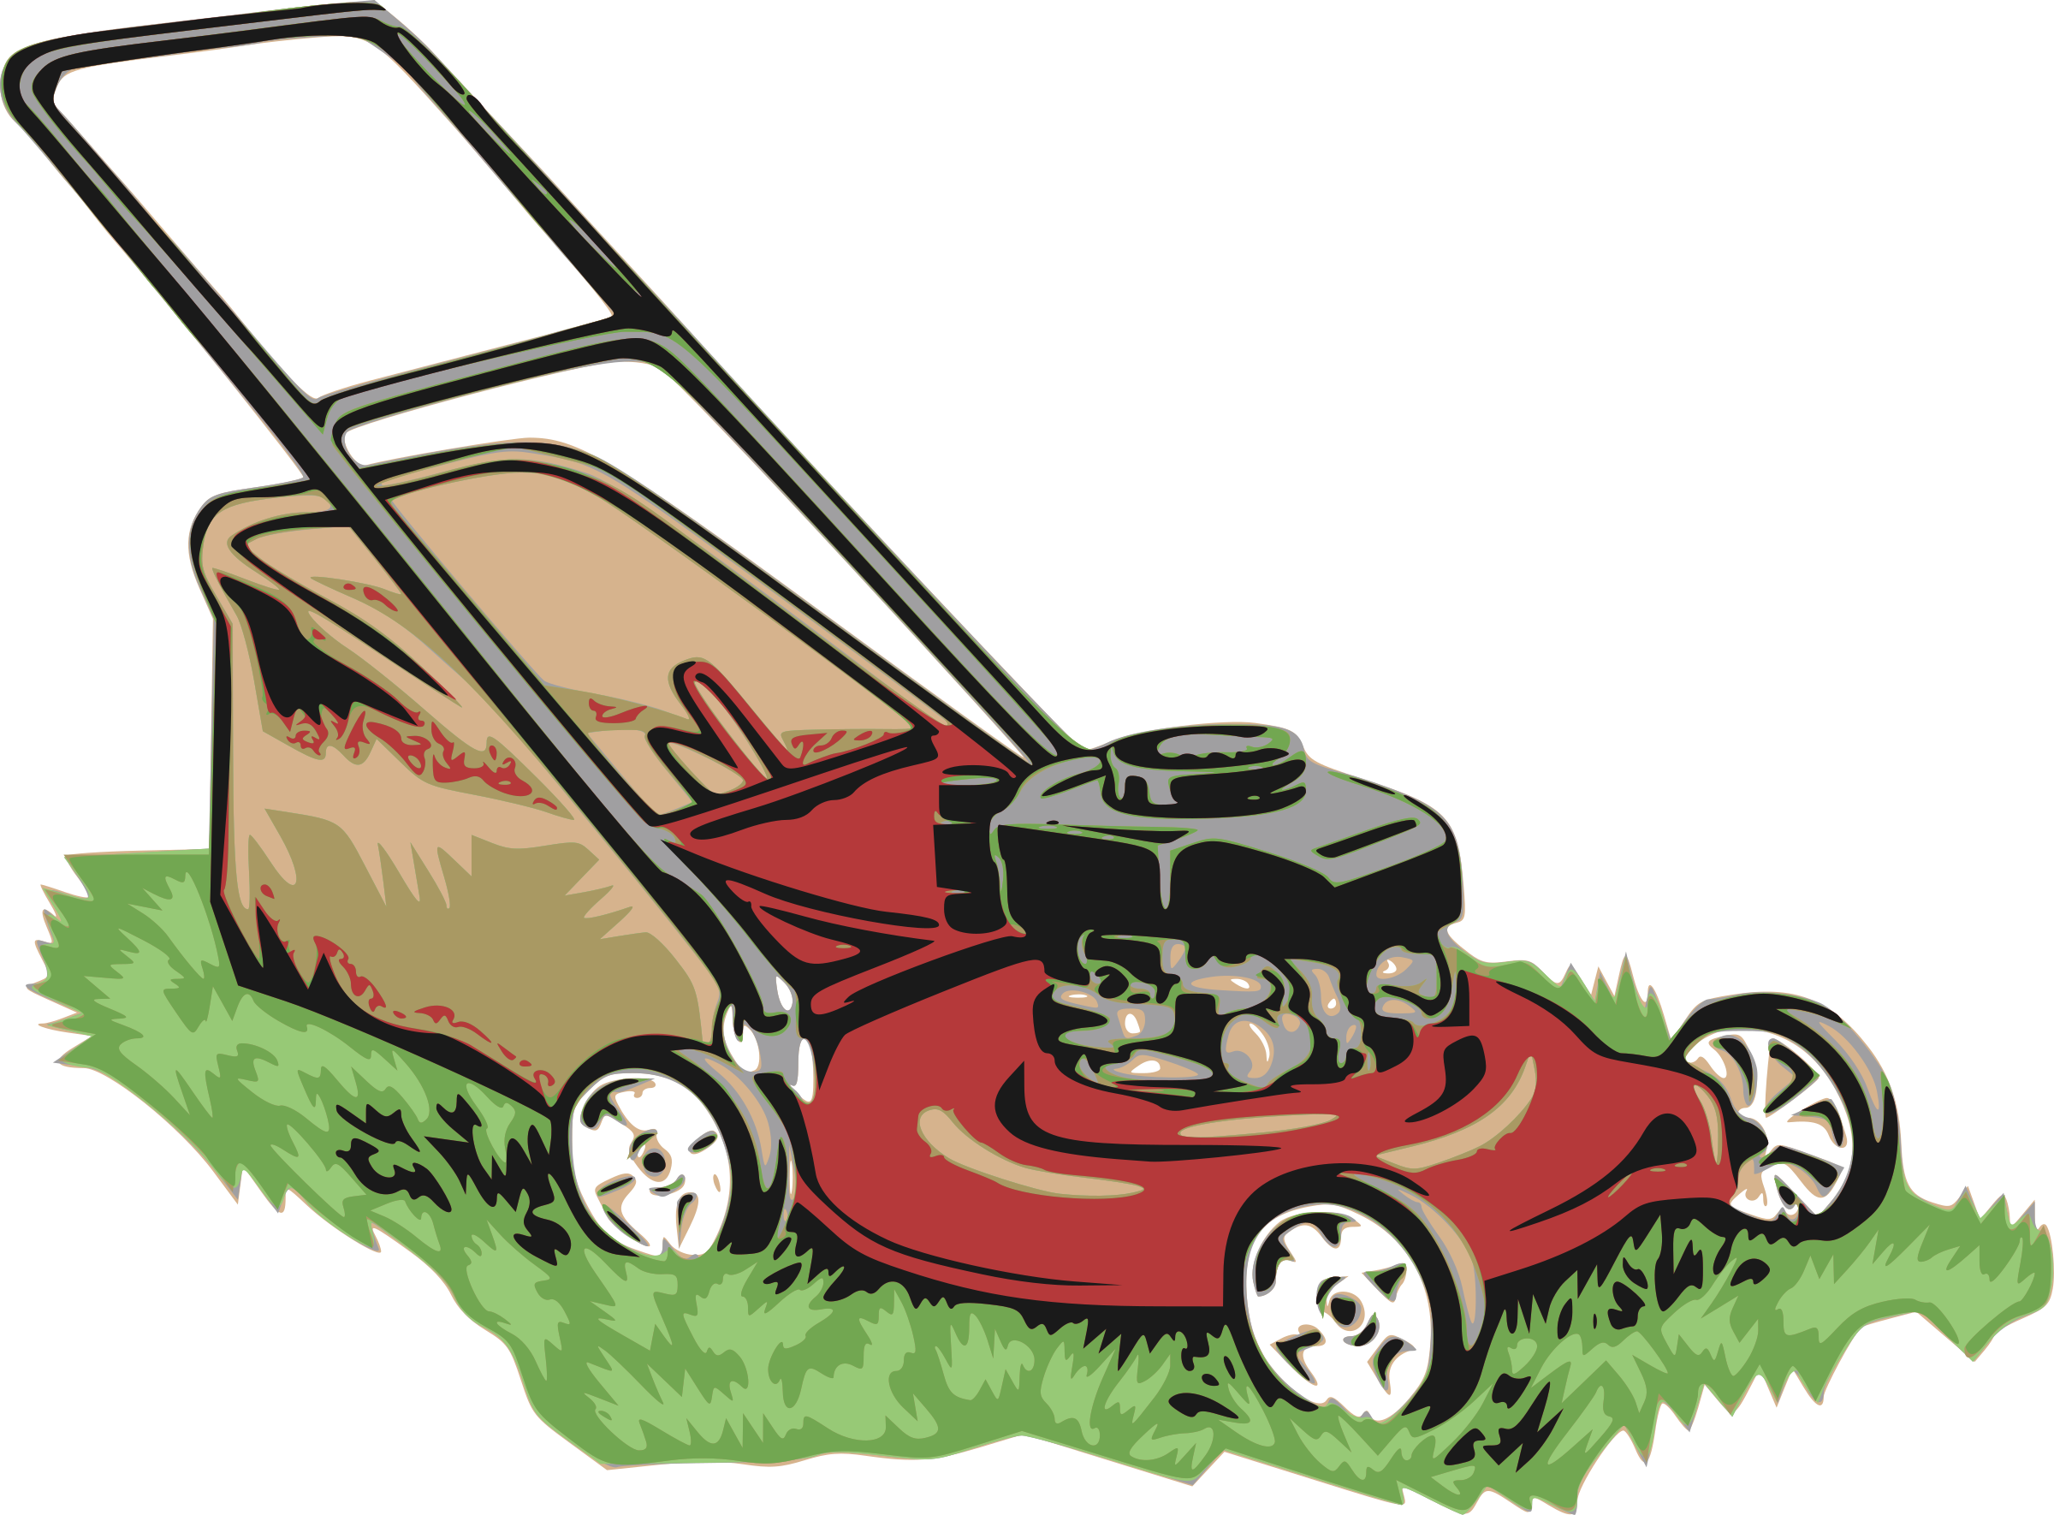

Please make sure your yards are all picked up for the contractor. It is your responsibility to pick up all toys, garden hoses, trash, etc., and will be considered a lease violation if the contractor cannot completely mow your area, nor are they responsible for items damaged.

The lawn care contractor is scheduled to mow on Mondays and Tuesdays (weather permitting) every 2 weeks

Thank you for making Comanche Housing Authority your Home! We appreciate your cooperation and enthusiasm.

