09/14/2018
NOTICE OF PUBLIC SALE: Eight (8) Single-Family Homes & Various Vacant Parcels of Land!

Eight (8) Single-Family Homes and Various Vacant Parcels of Land!
The Housing Authority of the City of Greenville, SC (TGHA) is offering for sale to the highest bidder eight (8) single family home properties and various vacant parcels of land included in Exhibit A – Form of Bid. These properties are owned by TGHA. Each property listed will be sold in “As-is, Where-is” condition.

INSTRUCTIONS: BIDS MUST BE SUBMITTED ON, OR BEFORE:

Monday, October 15, 2018 at 2:00 PM Local Time

Sealed bid envelopes marked as stipulated below shall be placed in a separate mailing envelope, sealed and mailed to:

The Greenville Housing Authority
122 Edinburgh Court
Greenville, SC 29607
Attention: Wanda Gardner

It shall be the sole responsibility of each bidder to ensure his/her bid(s) are received by TGHA on or before the stipulated deadline. All bids received will be publicly opened, read aloud and recorded at TGHA Administrative Office (address below). Bids received after this specific date and time will not be considered, or opened.

Interested bidders must complete the Form of Bid – Exhibits A & B inclusive of this notice. Exhibit B shall be specific to the legality of each property sale; therefore, the name of the bidder must be provided in the legal format desired for the title upon consummation of the sale. The Form of Bid shall be completed, signed and dated as indicated. Please list the property address exactly as listed on Exhibit A.

An earnest payment in the form of a cashier’s check, certified check or money order equal to 5% (five percent) of the total bid amount shall be submitted for each bid separately and addressed to: Housing Authority of the City of Greenville. Earnest Payment shall be in a sealed envelope for each property, attached to the completed Form of Bid (Exhibit B) along with Non-Collusive Affidavit and submitted at public bid opening. Each envelope shall be clearly marked as stipulated in the example below:

Bid for TGHA Property Sale
Specific Address(es) must be Listed

Attendance at public bid opening where bids are read aloud is NOT required. Interested bidders can bid on as many properties as they are prepared to purchase. Bids may be submitted via regular mail, overnight mail, or other similar means; or by personal delivery; however, all bids must be in sealed envelopes. It is the sole responsibility of the bidder to ensure delivery on, or before deadline. Electronic bid submissions are NOT acceptable; however, email notification to WandaG@tgha.net to expect delivery of actual bid submittal is acceptable.

ONE-TIME ONLY INSPECTION: Structure/house inspections will be scheduled to allow interior access for assessments by interested bidders.

Properties will be made available for access and inspection on Friday, September 28, 2018 ONLY. NO LATER THAN 10:00AM all interested bidders must arrive at the first location 34 Lone Tree Court – Greenville 29605. TGHA staff will guide interested bidders to each house until all eight (8) have been visited/entered.

Interested bidders MUST pre-register for the property inspections no later than one calendar day prior to the date of inspection, or no later than September 27th. Pre-registry will assist TGHA in allocating staff availability for these inspections. To pre-register for property inspections, submit notification to the e-mail address below. E-mail: BradW@tgha.net

Interested bidders may visit and inspect vacant parcels at their leisure.

Bid Awards - Each property is being offered in “As Is, Where Is” condition with no express or implied warranties. The highest bid will be accepted unless some unforeseen circumstance warrants rejection. In the event of equal high bids, the selection shall be randomly made by drawing lots immediately following the public bid opening.
Upon receipt of a valid bid, TGHA shall provide the bidder with written confirmation of an acceptable bid and intent to sell. TGHA will coordinate access to the property with successful bidder within 30 days. However, no bidder will be allowed to do any work at any property until Transfer of Ownership is complete.
Earnest funds will be returned within 15 business days from the date of bid opening for all bids that are not accepted.
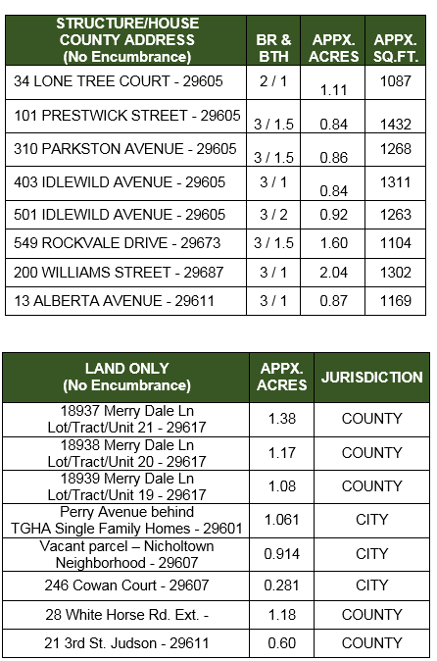

NOTE: Written questions must be transmitted to WandaG@tgha.net NO LATER THAN 10:00 AM, October 5, 2018. No later than seven (7) days prior to bid opening TGHA will respond to all questions in one (1) Addendum to this Notice of Public Sale. Any Addendum will be posted on our website www.tgha.net.
THE HOUSING AUTHORITY OF THE CITY OF GREENVILLE RESERVES THE RIGHT TO…
- REJECT ANY, OR ALL BIDS;
- CANCEL THIS NOTICE OF PUBLIC SALE AT ANY TIME IN WHOLE, OR IN PART;
- WAIVE MINOR INFORMALITIES IN THE BID PROCESS

